Top 1   
**Off The Wagon**

[Specialty & Gift Shops](http://www.tripadvisor.com/Attractions-g50499-Activities-c26-t144-Kent_Ohio.html), [Shopping](http://www.tripadvisor.com/Attractions-g50499-Activities-c26-Kent_Ohio.html)

Address: 152 E. Main Street, Kent, OH 44240

Phone Number: 330-474-1330

Website <http://www.offthewagonshop.com/#_=_>

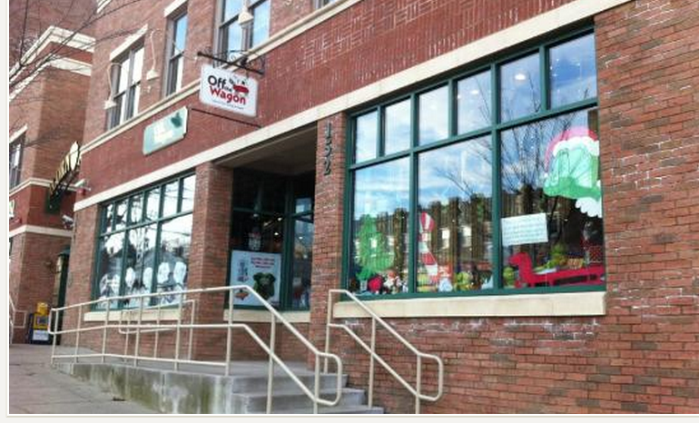

Top 2 **Laundry 101**

Address: 1683 State Route 59, Kent, OH 44240

Phone Number: 330.677.5588

Non website

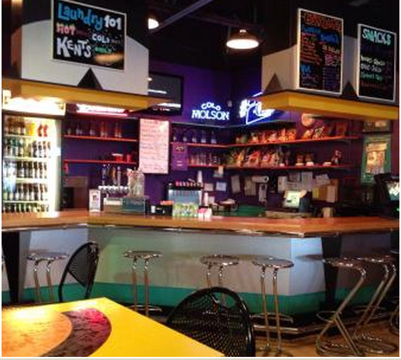  
Top3

**America's Unknown Destinations**

[Sightseeing Tours](http://www.tripadvisor.com/Attractions-g50499-Activities-c42-t139-Kent_Ohio.html), [Tours & Activities](http://www.tripadvisor.com/Attractions-g50499-Activities-c42-Kent_Ohio.html)

Address: 4187 Lynwood Road, Kent, OH

Phone Number: (330)-673-4180

Website <http://www.balloonfun.net/#_=_>



Top 4

**The Kent Stage**

Theaters, Theater& Concerts

Address: 175 East Main Street, Kent, OH 44240

Phone Number: (330) 677-5005

nowebsite

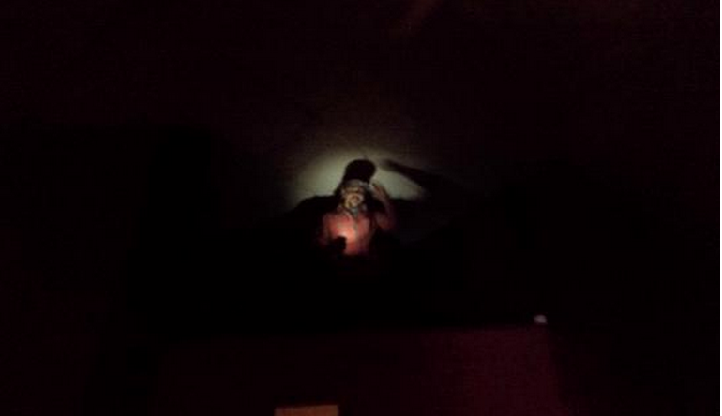

top5

**Kent Riverside Wine**

[Bars & Clubs](http://www.tripadvisor.com/Attractions-g50499-Activities-c20-t99-Kent_Ohio.html), [Nightlife](http://www.tripadvisor.com/Attractions-g50499-Activities-c20-Kent_Ohio.html)

Address: 911 N. Mantua, Kent, OH 44240

Phone Number: (330) 677-4400

Nowebsite

